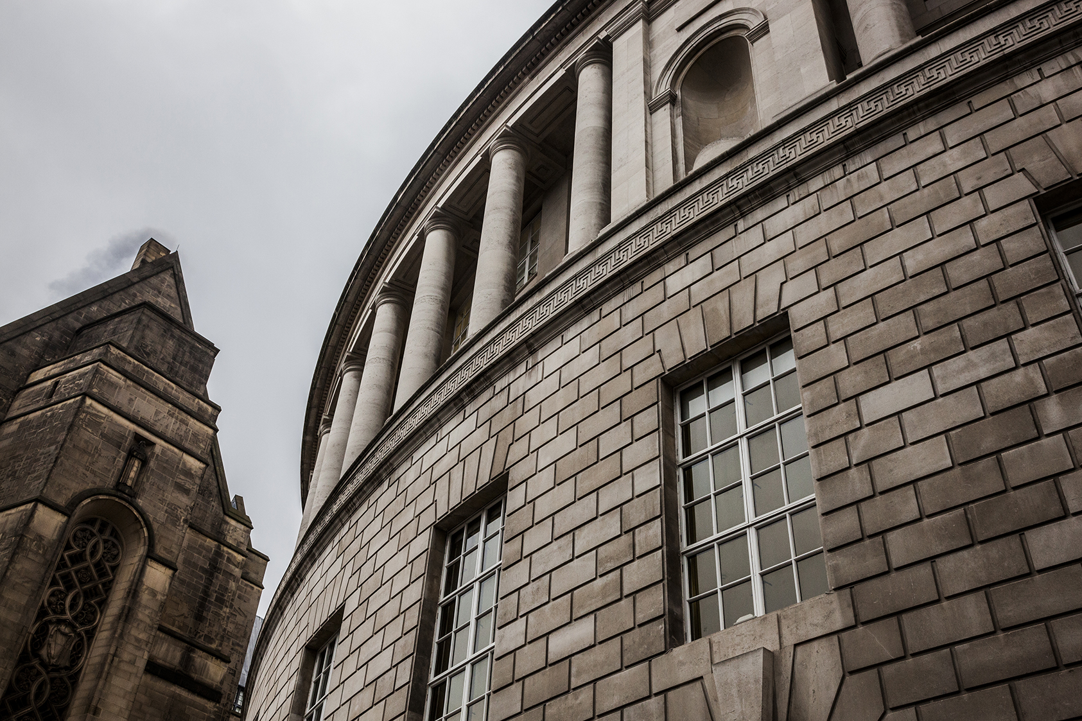


Approved Inspectors Ltd
Fire Authority Consultation Proforma

Fire Authority Consultation Proforma
We respectfully ask that you complete this proforma and return it to info@approvedinspectorsltd.co.uk. This procedure is necessary for Approved Inspectors Ltd to commence the statutory consultation with the Fire Authority. It is important that building works do not start until the completion of this consultation process.
- Project Details
Consultation Stage  (Note: If additional or design changes please quote the original FRS reference) | Choose an item.
 | Original Consultation Ref -
Full Site Address

Scope of Works
(As shown on the Initial Notice)
Client
(Name/Address/Phone/Email)

Principal Designer
(Name/Address/Phone/Email)

2.0 Project Information
Nature of Building Work | New Build  ☐ | Extension  ☐ | Material Alteration*  ☐ |  | Change of Use*  ☐
Fire safety design code used:  (If ‘other’ then please specify)  *Material Alteration as defined in Regulation 3 of the Building Regulations 2010 (as amended)  *Change of use as defined in Regulation 5 of the Building Regulations 2010 (as amended) |  |  |  | ADB V1 | ☐
 |  |  |  | ADB V2 | ☐
 |  |  |  | BS9999 | ☐
 |  |  |  | BS9991 | ☐
 |  |  |  | BS/PD 7974 | ☐
 |  |  |  | BB100 | ☐
 |  |  |  | HTM | ☐
 |  |  |  | Other

Please indicate the proposed evacuation strategy: | Choose an item.
Purpose Group / Risk Profile | Choose an item. Choose an item.
Approx. Total floor area (m2)
(See Diagram D3 – ADB)

Height to top storey (m)  (See Diagram D6 – ADB) | Choose an item.
Total no. of storeys  (Diagram D5 – ADB) | Choose an item.
No. of basement storeys  (Diagram D5 – ADB) | Choose an item.
Height of building (m)  (See Diagram D4 – ADB) | Choose an item.
Maximum occupants on each storey  (Complete as applicable) | Basement Storey -  Ground Storey -  1st Storey -  2nd Storey -  3rd Storey -  4th Storey -  5th Storey -  6th Storey -  7th Storey -  8th Storey -  9th Storey -  10th Storey -
Does the design deviate from the design document? | Choose an item.
 | If yes, please provide further details:
Has a performance based (fire engineered) solution been adopted? | Choose an item.
 | If yes, please include a fire strategy document with the submission from a qualified fire engineer.
Are internal linings to walls and ceilings designed to comply with the relevant design code? | Choose an item.
Are there any features considered as ‘compensatory’ in this submission e.g. to allow a relaxation in another area? | Choose an item.
 | If yes, please provide further details:
Main Method Of Construction
Please give details e.g. Masonry, timber frame, Steel Frame, Modern methods of construction etc

Fire Resistance to Structure
Please give details of how fire resistance is given to the structure. (E.g Plasterboard, Masonry, Paints)

Fire resistance of elements of structure (please indicate minimum levels) | Choose an item.
What fire protection measures are provided for escape routes and compartmentation (e.g., protected stairs, lobbies, corridors, compart wall/floors etc)?

Please provide plan references for the fire plan, if applicable
Is cladding used on any of the façades? | Choose an item.
 | If yes, please give specifications/details for the cladding products if relevant to the works.
Is the building subject to fire boundary conditions? | Choose an item.
 | If yes, please give specifications/details and unprotected area calculations.
Does Building Regulation 7(2) apply to any part of the proposal? | Choose an item.

3.0 Fire Suppression, Smoke Control, Fire Detection & other Fire Safety Systems

Does the Building feature a fire suppression system? | Choose an item.
 | If yes, provide general commentary and any areas of code deviation:
Type of Suppression Installation: | Choose an item.
 | Details of ‘other’ installation (where applicable) and standard installed to:
Details of Fire Alarm: | Category  Choose an item. | Design Standard  Choose an item.
Is emergency escape lighting proposed? | Choose an item.
 | If yes, provide general commentary including areas the lighting covers, the design guidance used for the design along with any areas of code deviation:
If the building features smoke control ventilation, please provide details of areas ventilated including the activation method

4.0 Access and Facilities for Firefighting
Are access routes provided in accordance with the design code? | Choose an item.
 | If no, provide details on how the functional requirement B5 will be met:
If fire mains are provided, please provide details including type, quantity and locations

If firefighting shafts are provided, please provide details

If the building has a basement and the design code requires smoke ventilation, please provide details.

Are additional water supply provisions in accordance with the design code? (Where applicable) | Choose an item.
 | If yes, please confirm water supply and location.
 | If no, provide details on how the functional requirement B5 will be met:

5.0 Building Regulation Compliance Declaration
As a duty holder responsible for Building Regulation compliance, I hereby affirm that the information provided in this document is accurate and complete to the best of my knowledge and understanding. Furthermore, I confirm the design complies with the applicable fire safety requirements outlined in Schedule 1 of the Building Regulations 2010(as amended).

Name…………………..

Date……………………

Project Role……………….

Appendices
Diagram D3 from Approved Document Part B
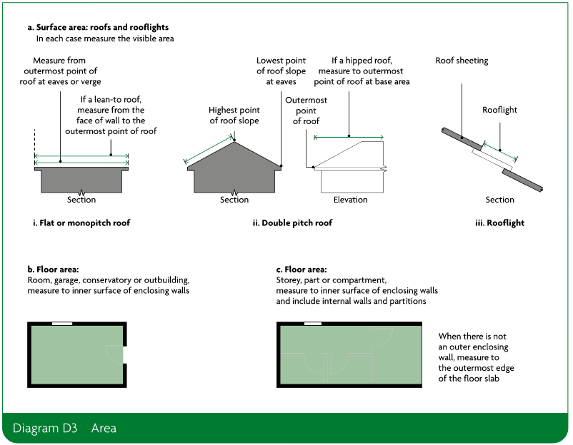

Diagram D4 from Approved Document Part B
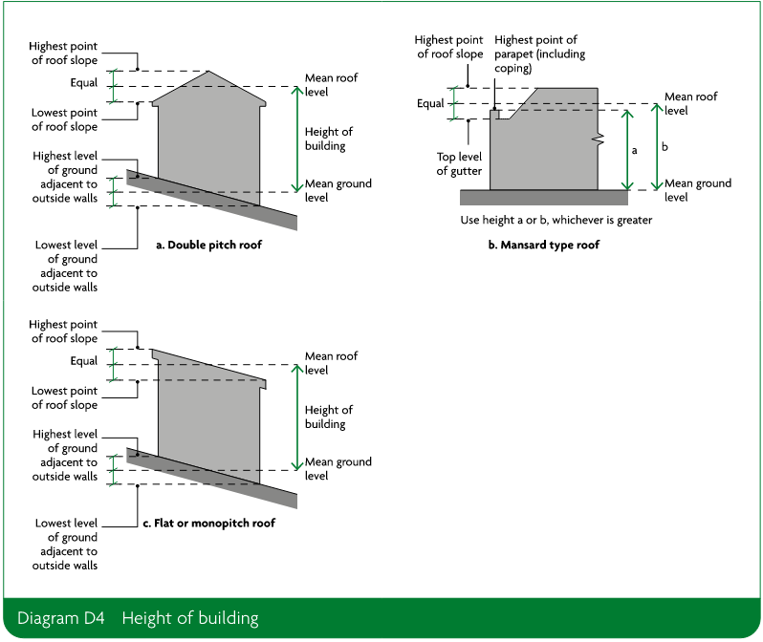

Diagram D5 from Approved Document Part B
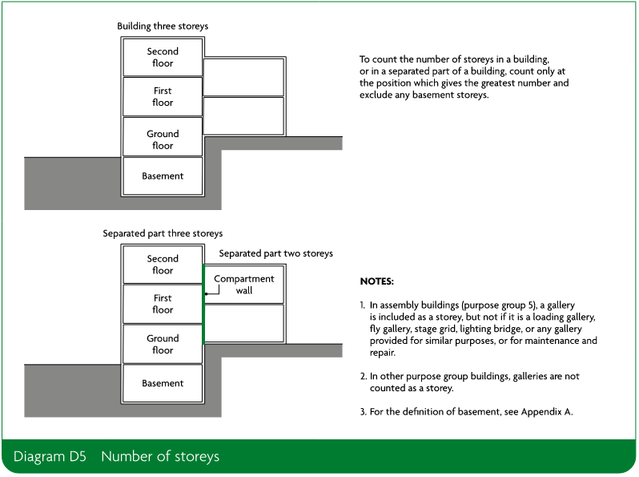
Diagram D6 from Approved Document Part B
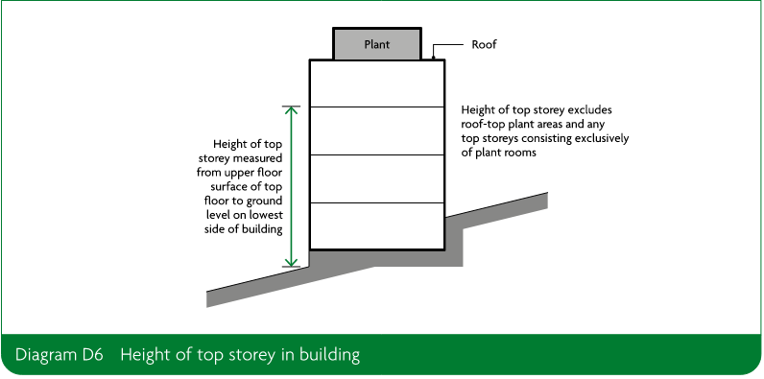
Regulation 7(2) of the Building Regulations 2010 Definition
(2) Subject to paragraph (3), building work shall be carried out so that materials which become part of an external wall, or specified attachment, of a relevant building are of European Classification A2-s1, d0 or A1 (classified in accordance with the reaction to fire classification).
(3) Paragraph (2) does not apply to—
(a) cavity trays when used between two leaves of masonry;
(b) any part of a roof (other than any part of a roof which falls within paragraph (iv) of regulation 2(6)) if that part is connected to an external wall;
(c) door frames and doors;
(d) electrical installations;
(da) fibre optic cables;
(e) insulation and waterproofing materials used below ground level or up to 300mm above that level;
(f) intumescent and fire stopping materials where the inclusion of the materials is necessary to meet the requirements of Part B of Schedule 1;
(g) membranes;
(h) seals, gaskets, fixings, sealants and backer rods;
(ha) components associated with a solar shading device, excluding components whose primary function is to provide shade or deflect sunlight, such as the awning curtain or slats;
(i) thermal break materials where the inclusion of the materials is necessary to meet the thermal bridging requirements of Part L of Schedule 1;
(j) window frames and glass; or
(k) materials which form the top horizontal floor layer of a balcony which are of European Classification A1fl or A2fl-sl (classified in accordance with the reaction to fire classification) provided that the entire layer has an imperforate substrate under it.
(4) In this regulation—
(a) a “relevant building” means a building with a storey (not including roof-top plant areas or any storey consisting exclusively of plant rooms) at least 18 metres above ground level and which—
(i) contains one or more dwellings;
(ii) contains an institution; or
(iii) contains a room for residential purposes; and
(b) “above ground level” in relation to a storey means above ground level when measured from the lowest ground level adjoining the outside of a building to the top of the floor surface of the storey.

